District 62 Structure Manual 2022

DISTRICT 62

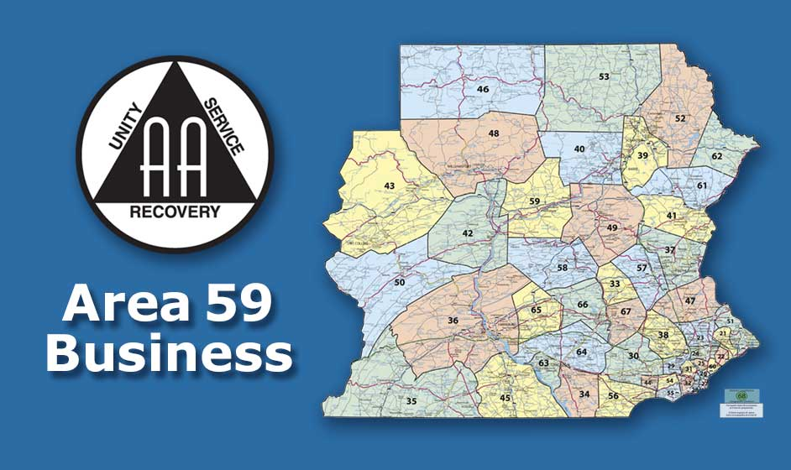

Structure Manual
2022

District 62 Structure Manual 2022

Table Of Contents

Table Of Contents……………….......…………………………………….......…2

GSR……………………………………………………………………………………..3

Alternate GSR………………………………………………………………………3

Organizational Chart…………………………………………………………….4

Officers…………………………………………………………………………….5-7

District Meeting Format………………………………………………………..8

District Meeting Procedures…………………………………………………9

Election Procedure………………………………………………………….9-10

District Responsibilities and Etiquette…………………………………11

Website Guidelines………………………………………………………..12-13

Declaration of Unity and Preamble……………………………………...14

District 62 Structure Manual 2022

The General Service Representative (GSR)
(See: The “AA Service Manual” – Current Edition)

The GSR is a vital part of AA. They serve as the link between the Group and the District. Each Group elects its own GSR. It is usually a two (2) year commitment, and it is suggested they have at least two (2) years sobriety. They are the guardians of the AA Traditions. Also see the pamphlet “G.S.R.” and “The A.A. Group”.

- Regular attendance at their Group
- Attendance at Group Monthly Business Meetings
- To understand Group Conscience and take back to the district
- Brings all appropriate handouts back to the Group
- To share their service experience with the Group
- Attendance at Monthly District Business Meeting
- Gives Group Status Report at District Meeting
- Brings Group announcements to District Meetings
- Attends yearly E.P.G.S.A Area Convention/Assembly
- Attends at least one (1) Area Business Meeting
- Attends at least one (1) Mini-Assembly

The Alternate GSR (See GSR Description)

The Alternate GSR role is two parts. The first is to back up the GSR in case they are unable to fulfill a commitment. For example, if the GSR cannot attend the District Business Meeting, it is the alternate GSR duty to attend. The second role is to step into the GSR position if the GSR resigns. Suggested time of sobriety is one (1) year, depending on Group Conscience.

- Regular attendance at their Group
- Fills in for GSR when unable to fulfill commitment
- Attendance at Group Monthly Business Meetings
- To Share their service experience with the Group
- Recommended Attendance at Monthly District Business Meetings
- Suggested Attendance at yearly Area E.P.G.S.A Convention/Assembly
- Suggested attends at least one (1) Area Business Meeting
- Suggested attends at least one (1) Mini-Assembly

District 62 Structure Manual 2022

Organizational Chart

THE GROUP
THE GSR
DISTRICT 62
GSR Secretary
Officer At Large ADCM
Treasurer DCM
THE DCM
AREA 59
DCM Treasurer
Officer At Large Chairperson
Secretary The Alt Delegate
The Delegate
THE DELEGATE
GENERAL SERVICE CONFERENCE

District 62 Structure Manual 2022

District 62 Officers

DCM - Liaison between District/GSR and Area Delegate (5 Years Sobriety Requirement)

ACDM - Backup for DCM and steps up to the position if DCM resigns (3 Years Sobriety Requirement)

Secretary - District Record Keeper (3 Years Sobriety Requirement)

Treasurer - Maintains District’s funds (3 Years Sobriety Requirement)

Officer at Large - Chairs monthly District meeting and fills District officer position if anyone other than the DCM resigns (3 Years Sobriety Requirement)

*If no candidate is available with the minimum sobriety requirements, then the voting body can waive this requirement, provided the potential candidate has good sobriety and is familiar with the AA Service Manual (current edition).

DCM - District Committee Member (See: “The A.A. Service Manual” – Current Edition)

District Level Duties (including but not limited to):
- Holds Monthly District Meeting
- Chairs Monthly District Meeting (if no Officer At Large)
- Gives DCM Report during meeting
- Gets guest speakers for District Meeting as required/requested
- Represents the District as Spokesperson in all matters
- Makes written report of all Area 59 and G.S.O. functions to be published on the district website

Area Level Duties (including, but not limited to):
- Attends Quarterly Area 59 Meeting
- Gives District Report – verbal and written
- Participates in Mini - Assemblies, Share A Day, Multi-District Workshops and E.P.G.S.A Convention/Assembly

District 62 Structure Manual 2022

ADCM - Alternate District Committee Member (See: “The A.A. Service Manual” -Current Edition)

District Level Duties (including, but not limited to):
- Attends Monthly District Meeting
- Gives ADCM Report during meeting
- Participates in District Workshop

Area Level Duties (including but not limited to):
- Attends Area 59 Meetings with DCM
- Participates in Mini-Assemblies, Share A Day, Multi-District Workshops and E.P.G.S.A. Convention Assembly

Secretary

District Level Duties (including but not limited to):
- Attends Monthly District Meeting
- Keeps minutes of District Meeting
- Copies and distributes monthly minutes to each GSR and District Officers
- Reads previous months minutes at monthly District Business Meeting
- Fulfills all other District correspondence as directed
- Maintains GSR contact list for distribution (if no Officer At Large)

Area Level Duties (including but not limited to):
- Attends at least one (1) Area 59 Meeting
- Participates in Mini-Assemblies, Share A Day, Multi-District Workshops and E.P.G.S.A Convention/Assembly
- Copies and distributes monthly minutes to Area 59 officers

District 62 Structure Manual 2022

Treasurer

District Level Duties (including but not limited to):
- Attends Monthly District Meeting
- Gives Treasurer’s Report (Verbal and Written)
- Speaks on 7th Tradition each month at District Meeting
- Collects Donations from District Groups and sends thank-you notes
- Pays District Expenses
- Maintains and balances District checkbook

Area Level Duties (including but not limited to):
- Attends at least one (1) Area 59 Meeting
- Participates in Mini-Assemblies, Share A Day, Multi-District Workshops and E.P.G.S.A Convention/Assembly

Officer-At-Large

District Level Duties (including but not limited to):
- Chairs Monthly District Meeting
- Maintains GSR contact list for distribution
- Fills any position (except DCM) if District Officer resigns or is temporarily unavailable to fulfill their duties. The OAL will take over vacant position temporarily until the position is filled by the election of GSR or Alternate GSR
- Participates in the preparation of the annual District budget

*The budget is a vital tool that the district will be using to steer most, if not all, of the service work that the district will perform. It is prudent and responsible to have the preparation be a joint effort of the current District committee member/officer panel.

District Information Technologies Servant (Duties will be listed under Website Guidelines)

District 62 Structure Manual 2022

District Meeting Format

The District 62 Monthly Business Meetings are being held on the third Thursday of each month at 6pm on Zoom. All District Officers, GSR, and alternate GSR should be in attendance. The Officer At Large (OAL) will be the Chairperson. The DCM will chair if there is no Officer At Large. If the DCM is not present, the chairing order will be ADCM, Secretary and then the Treasurer.

- The Chairperson will call the meeting to order
- The Chairperson leads the Serenity Prayer
- The Chairperson will read, or appoint, a GSR to read the Tradition corresponding to the month and discussion will follow
- The Chairperson will read, or appoint, a GSR to read the Concept corresponding to the month and discussion will follow
- Roll Call of District Officers and Group reports by Secretary
- Groups having “Issues and Answer” should make notice at this time
- Call for any Groups missed
- Secretary will ask if any GSR has not received a copy of the previous months District meeting minutes and have reviewed them
- Secretary will ask if there are any changes to note
- Secretary will read previous months minutes; a vote will be taken to approve minutes into record
- Treasurer’s report and 7th Tradition will be announced, address will be posted
- The DCM, ADCM and OAL Reports will be given at this time
- Special Reports and or Issues and Answers
- Old Business
- New Business
- Call for District related Issue by anyone who is not a GSR or District Officer
- Chairperson asks for GSR or Officer to volunteer to do next month’s Tradition reading
- Chairperson asks for GSR or Officer to volunteer to do next month’s Concept reading
- Chairperson to ask for coffee commitment
- Motion to end meeting
- Meeting adjourned with Responsibility Pledge

District 62 Structure Manual 2022

District 62 Meeting Procedures

- Meeting time is limited to one (1) hour. Any overage must be voted on and approved.
- Only GSR, acting Alternate GSR and District Officers may sit at the tables and speak, to keep participation limited to those representing Groups. Also, to aid in counting during any voting.
- Robert’s Rules of Order are used as a guideline:
- Motion Procedure: 1) Motion brought to floor, 2) a second to the motion is made, for discussion to proceed, 3) call, if motion remains, 4) call for vote. Each GSR or acting Alternate GSR and District Officers all have one vote.
- Any amendments to a motion, under consideration, can be done during the discussion (example: “I move to amend the motion on the floor”), and requires a second.
- A simple majority vote is required for a motion to pass.
- After a vote has been taken, minority option will be heard, at which time, another vote may be taken if any wish to change their vote.
- Any amendment to the Structure Manual, or any item on the floor, will be passed by a majority vote only. Abstentions will not be counted in final vote.
- Questions on procedure will be answered by the OAL. If the OAL does not know the answer, or isn’t present, the structure committee will advise along with the District Officers.
- If any GSR arrives after the Group reports, they must wait until after the Treasurer’s report. If they are later than that, it is up to the Secretary/OAL to fit them in before the end of the meeting.

District 62 Election Procedure

There are five (6) elected positions at the district level, elected every two (2) years. (See Section on District Officers) The election is held on even-numbered years, coinciding with the Area 59 Delegate and Officers election.

DCM - Liaison between District/ GSR’s and Area Delegate (5 years sobriety requirement)
ADCM - Backup for DCM & steps up to position if DCM resigns (3 years sobriety requirement)
Secretary - District record keeper (3 years sobriety requirement)
Treasurer - Maintains District’s funds (3 years sobriety requirement)
Officer At Large - Chairs monthly District meeting and fills District Officer position if anyone other than DCM resigns (3 years sobriety requirement)
District Information Technologies Servant (3 years sobriety requirement)

District 62 Structure Manual 2022

Eligibility
- Eligibility to Run: District Officers, (except outgoing DCM) and all present GSR members. In the event no GSR members accept a position, the election chair will open the position to present Alternate GSR members.
- Eligibility to Vote: Each group should have one vote – GSR, Alternate GSR, designated representatives, and District Officers.
- To be elected, the nominee must be present at the election meeting to be able to accept or decline.

Nominations
- At the September meeting, as part of “New Business”, the OAL (or the meeting Chairperson) will bring up the topic of elections. A brief explanation will take place, with Q&A to follow.
- At the October meeting, the OAL (or Chairperson) will bring up nominations as part of “Old Business: and at this juncture the Chairperson will turn the meeting over to the Election Chairperson to chair the election.

Elections – Will be part of the October District Meeting, with time extensions voted as needed.

- Voting will be simple majority vote/show of hands.
- Elections will be held after “New Business” section of format, so as all business of District will be completed.
- Elections for each position, starting with DCM and proceeding to ADCM, Secretary, Treasurer and Officer At Large.
- Each eligible District Officer and GSR will accept or decline the nomination.
- Following nominations, voting will take place.

Rotation Of Officers
- New officers will be seated during New Business in November meeting. New and old officers will be present during November meeting to augment a smooth transition.
- When a District Officer resigns, other than the DCM, within a period of two (2) months there will be a special District election to fill the position that has been vacated. The only positions to be filled by special elections – ADCM, Treasurer or Secretary. This will also apply to Officer At Large. (OAL)
- When the DCM voluntarily resigns before term expiration, the ADCM will step up to the position for the remainder of the term. (until the next election cycle)

District 62 Structure Manual 2022

District Responsibilities / Etiquette

- All expenses must be presented to and approved by District 62
- Sending the DCM or ADCM to the Annual Area 59 Conference/Assembly.
(full fee and expenses - E.P.G.S.A.)
- Sending the District Secretary, Treasurer and Officer at Large to the Annual Area 59 Conference/ Assembly. (one day registration - E.P.G.S.A.)
- Sending DCM or ADCM to Area Meetings, Mini-Assembly and Area Day.
- Travel expenses for the above events are to be included in the yearly budget
- Mileage reimbursement for ADCM and/or DCM will be the current IRS rate. (March 2022)
- At District meetings, group representatives (GSR, Alt. GSR, etc.) will speak only when recognized by the Chairperson.
- District Meetings should be set up one-half (1/2) hour before meeting time
- District 62 believes in the spirit of rotation and encourages all their members to get involved in service and share responsibilities.
- District 62 believes strongly in the Traditions of AA and endeavors to uphold the Traditions in all its affairs and encourages all its members to gain an understanding of the Traditions.

Amending Structure Process

All the requests for amending the Structure Manual must be presented to the Structure Committee at the District meeting. The requests should be written but may be verbal if properly recorded.

The Structure Committee will review the request, holding in mind the Traditions, consulting with District Officers, Area Officers and other members as needed.

At the next District Meeting, after the request has been put to the Structure Committee, the committee advises the meeting participants of the request. The committee will continue to include the request in its report if the request is under consideration. The committee, upon reaching a consensus, will advise the district meeting of their decision. Opposition will be qualified by majority vote.

District 62 Structure Manual 2022

Area 59 District 62 Website Guidelines

- The spirit of A.A. principles and traditions will be always followed.
- Anonymity will be preserved and protected: the complete names of individuals, individual phone numbers, postal and identifying email addresses will not be displayed on the Website.
- There will be no endorsement or affiliation with non A.A. entities. Autonomy will be respected. The Website will not link to websites not sponsored by genuine A.A. services entities.
- The Home Page will identify the Website’s focus on A.A. within Area 59 District 62, making it clear there is no attempt to speak for A.A. as a whole. A link to the A.A.W.S.’s website (www.aa.org) will be provided to access general information about A.A.
- Copyrights shall be respected and registered trademarks, when used, should be acknowledged as such. (For example: Alcoholics Anonymous®, A.A.® and The Big Book® are registered trademarks of Alcoholics Anonymous World Services, Inc. The Grapevine® and AA Grapevine® are registered trademarks of The A.A. Grapevine, Inc.)
- This Structure Manual contains information that is also approved for display on the District 62 Website: (www.district62aa.net) and other type of information is not allowed.
- Group meeting information: type of meeting, time and location.
- District meeting time and location.
- Event information (location, time, agenda, registration form, etc.) for the following types of activities primarily focused on events in Area 59: A.A. general service functions. (assemblies, conferences, special forums, workshops, etc.)
- District Committee reports, elected officer reports and standing committee reports, etc.
- Links to websites sponsored by genuine A.A. service entities will be provided as a service to the website user.

District 62 Structure Manual 2022

Domain Name Registration
- The Website shall be registered to Area 59 District 62 with a domain name of district62aa.net.
- The Area 59 District 62 Information Technologies Servant shall be the Administrative Contact for the Website’s domain name.
- The Area 59 District 62 Information Technologies Servant shall be the Billing Contact for the Website’s domain name.
- The Hosting Company who maintains the primary domain name, will provide services to the registrant (District 62) as outlined in the contract when the domain was purchased.
- The Registration will be held in a private registered account so that no personal information will be revealed to the general public.

Administration and Maintenance
The District Information Technologies Servant - shall have direct oversight on all matters pertaining to the Website. Specific responsibilities for the District Information Technologies Servant include, but are not limited to, the following administrative duties:
- Verify the Website adheres to these guidelines and A.A.’s Traditions.
- Ensure website expenses are paid and do not exceed the budget without approval.
- Mediate differences of opinion regarding the information displayed on the website and the services it provides.
- Give website status reports at all District 62 Meetings.

District 62 Structure Manual 2022

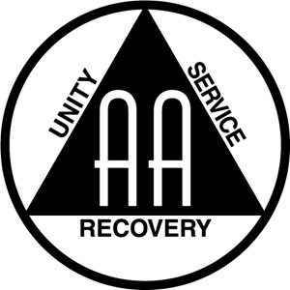

A Declaration of Unity

This we owe to A.A.’s future.
To place our common welfare first.
To keep our fellowship united.
For on A.A. unity depend our lives,
And the lives of those to come.

Copyright © Alcoholics Anonymous World Services, Inc.

Preamble

Alcoholics Anonymous is a fellowship of people who share their experience, strength and hope with each other that they may solve their common problem and help others to recover from alcoholism.
The only requirement for membership is a desire to stop drinking. There are no dues or fees for A.A. membership; we are self- supporting through our own contributions. A.A. is not allied with any sect, denomination, politics, organization or institution; does not wish to engage in any controversy, neither endorses nor opposes any causes. Our primary purpose is to stay sober and help other alcoholics to achieve sobriety.
Copyright © The AA Grapevine, Inc.

